St. Thomas Centre Nursery School
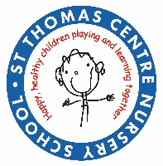
St. Thomas Centre Nursery School
Bell Barn Road, Lee Bank,
Birmingham, B15 2AF.
Tel: 0121 464 0003
Email: enquiry@stcn.bham.sch.uk
website – www.stthomascentrenursery.co.uk
Executive Head teacher: Laura O’Neill

Executive Head teacher: Laura O’Neill

Tuesday 23rd June 2026

Dear Parent/ Carer,
Following a risk assessment and the latest weather forecast, we have made the decision to close the nursery from 12:30pm on Wednesday 24th June and Thursday 25th June.

The safety and wellbeing of our children, families, and staff is our priority, and we believe this is the most appropriate course of action given the expected conditions.

We apologise for any inconvenience this may cause and appreciate your understanding and cooperation.

If there are any further updates, we will communicate these with you as soon as possible.

Kind regards,

Laura O’Neill

Executive Head Teacher




